

**Final Assignment**

**Course: Database Management System**

**Course Code: CSE311**

Faculty: Nda

Topic: A2ZFilms Management Systems

**Submitted by:**

Name: Mohammad Shaikhul Fuad

ID: 1812080042

Section: 05

**INDEX**

**Content Page Number**

1. Project title and description 03
2. ER Diagram 04
3. Schema Diagram 05
4. Queries 06-21
5. Appendix 22-29

A2ZFilms Management System

A2ZFilms is a film production and publication house. It produces Hollywood films. A film cannot be made without a producer or a production company. This management system holds all the film records that have only been released to Hollywood through this company till now. A film is also not possible without the help of a director and cinematographer. Corresponding to the films it also holds all the Directors and Cinematographer records who have worked for their company so far. A2ZFilms also holds their Agent records. Agent who works for them or approaches new directors and gives them this production company to make films. Agent is needed for the debut directors or, the directors who do not belong to the film industry before. The agent is the best help for the new directors to let their film script reach any producer. The directors who already belong to the film industry do not need an agent to reach any production company.

**Entities**

**Movies:** It contains information like movie name, genre, runtime, release date, director id and cinematographer id for a movie.

**Director:** It has director name, id, and director age and agent id.

**Cinematographer:** It contains cinematographer name, id, and age.

**Business:** It holds business rate of a movie like budget, box-office collection, hit or flop.

**Agent:** It holds agent name, id, and age.

A director can be either approached or not approached by agent. If approached it means new director, if not it means old director. The directors who do not have any agent the value would be Null in record. A director can have multiple films of this company. Also an agent can approach many directors but a director can only have one agent.

ER Diagram

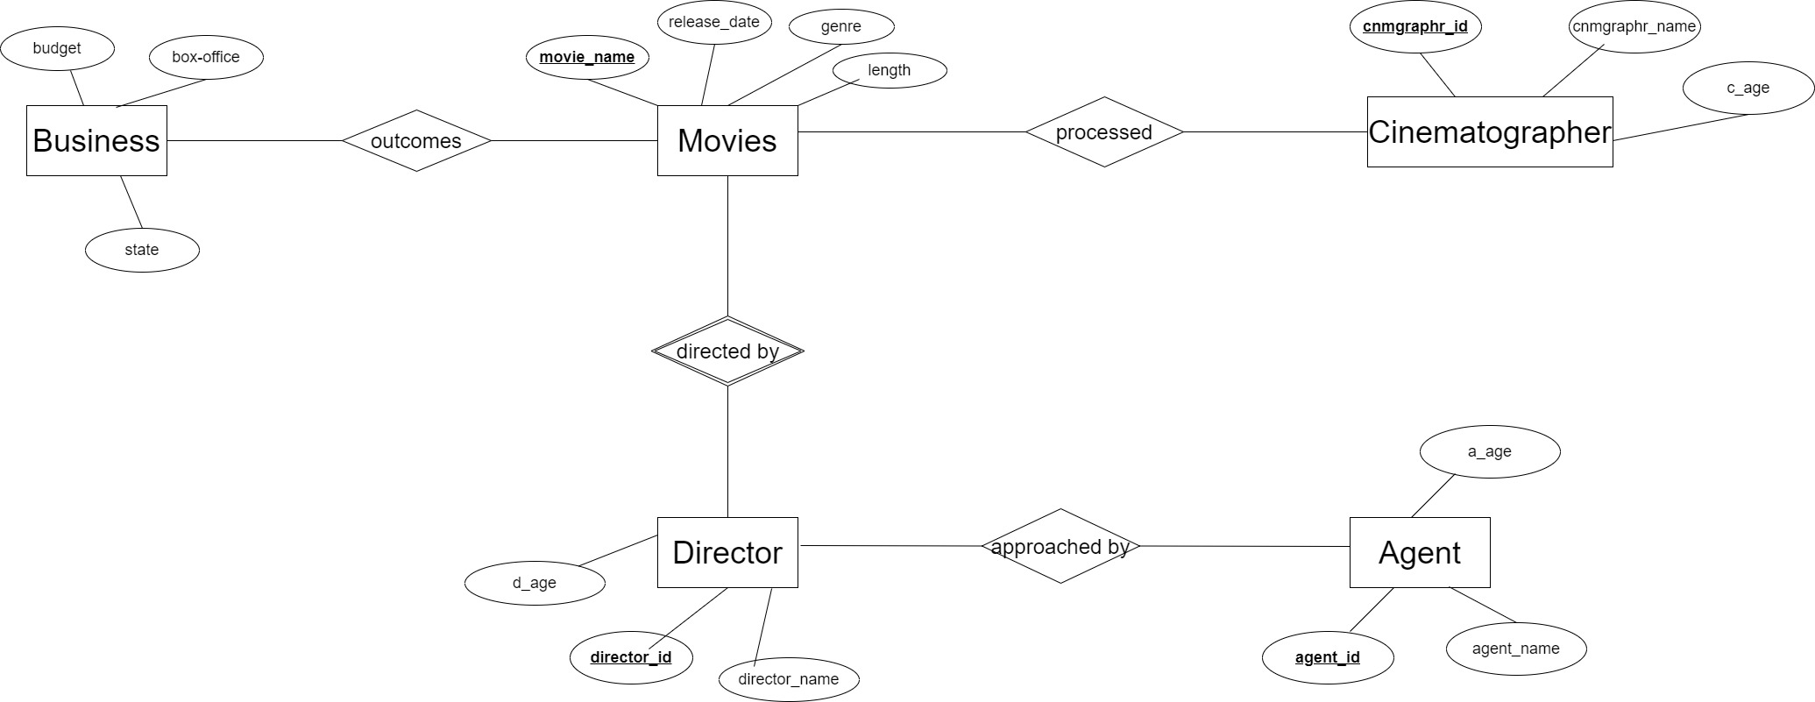

Schema Diagram

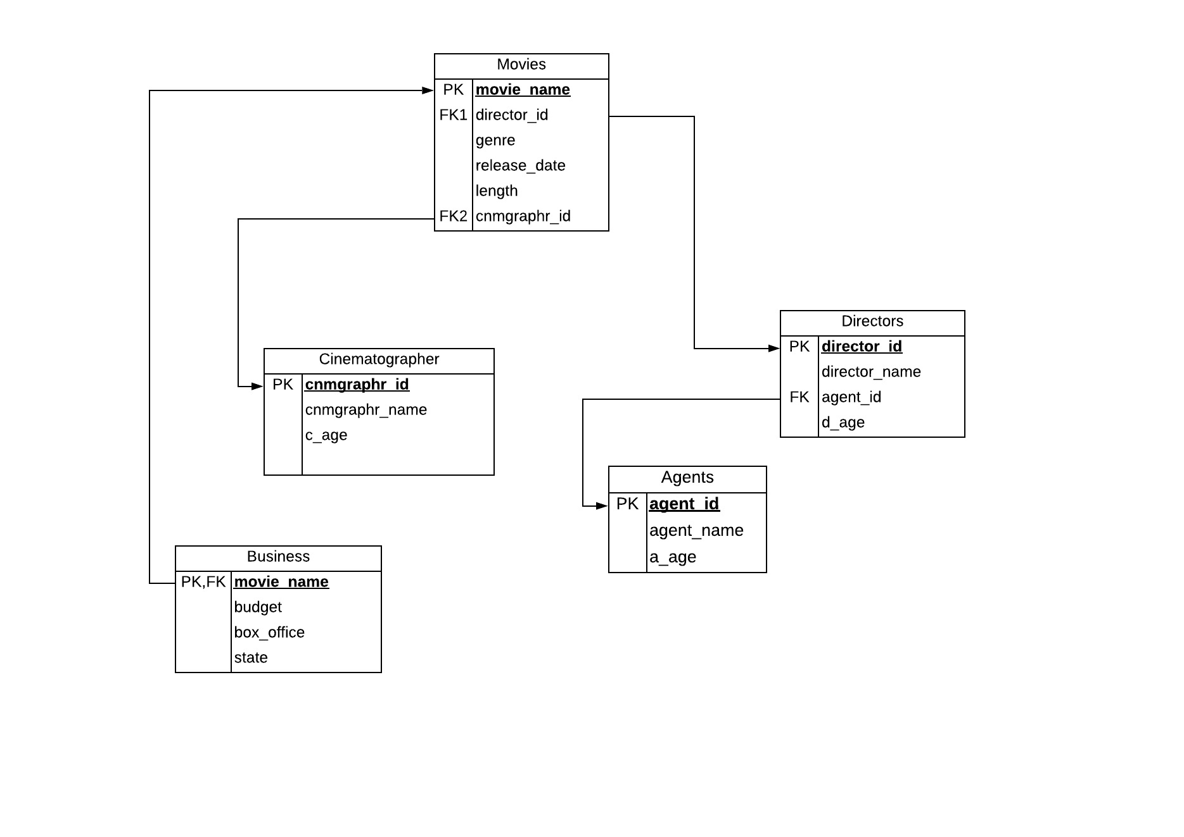

**Queries**

1. Show all the movies and their records that have release from A2ZFIlms.

Select * from movies.

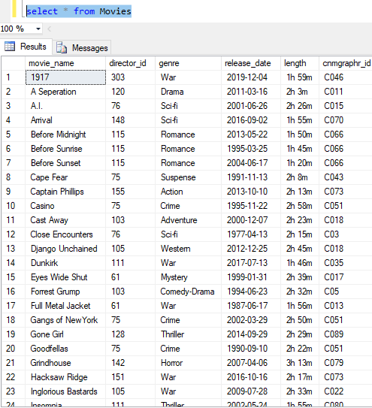

1. Show only the unique cinematographer id from the movie table.

Select distinct cnmgraphr_id from movies.

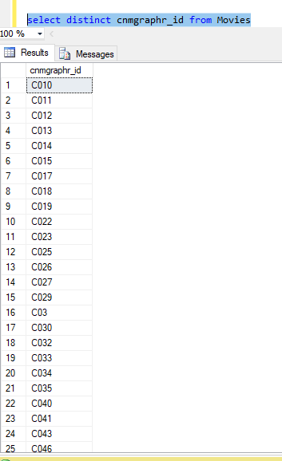

1. Show movies and their release date in the crime genre.

Select movie_name, release_date, genre from movies where genre=’Crime’.

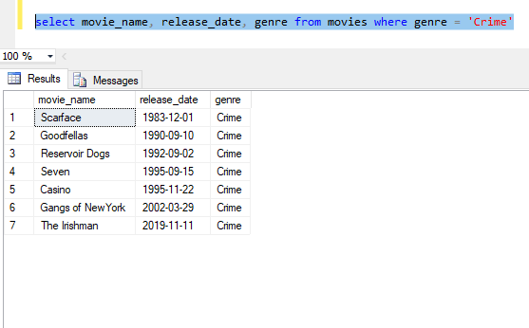

1. Show all the movies and their director name that have been released.

Select m.movie_name, d.director_name from Movies m, Directors d where m.director_id=d.director_id.

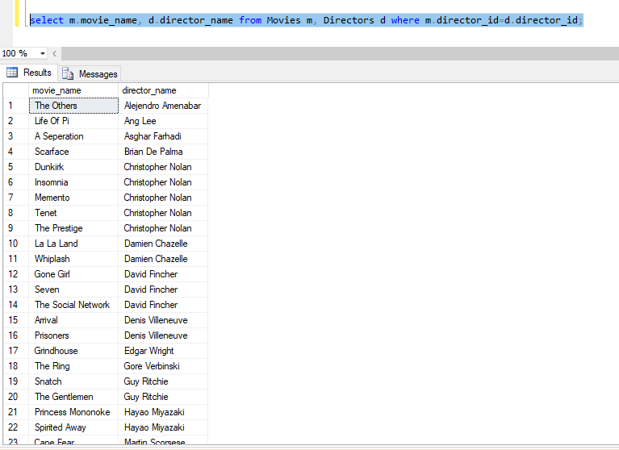

1. Show the movie name, release date, and its runtime Steven Spielberg has directed.

Select m.movie_name, m.release_date, m.length, d.director_name from Movies m, Directors d where m.director_id = d.director_id and d.director_name = ‘Steven Spielberg’.

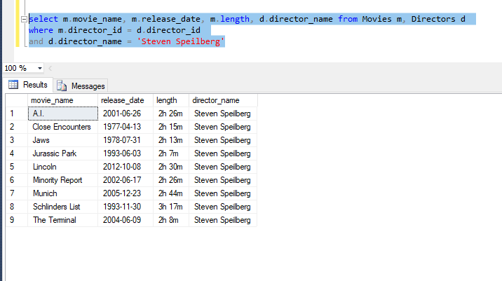

1. Show movie names and their corresponding director and cinematographer name where both cinematographer and director age equal and greater than 50?

Select m.movie_name, d.director_name,d.d_age,c.cnmgraphr_name, c.c_age from Movies m Join Directors d on(m.director_id=d.director_id) Join Cinematographer c on(d.d_age=c.c_age) where d.d_age>50

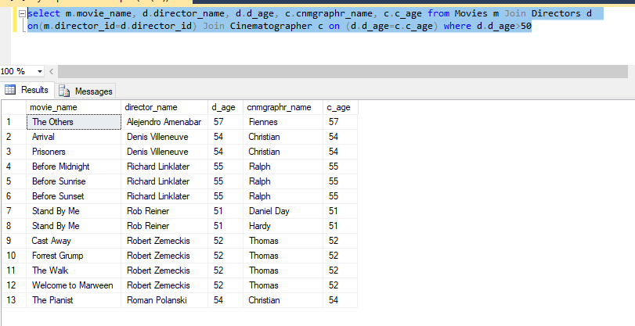

1. Show the movie that goes three hours in runtime.

Select movie_name, length from Movies where length Like ‘3h_%’

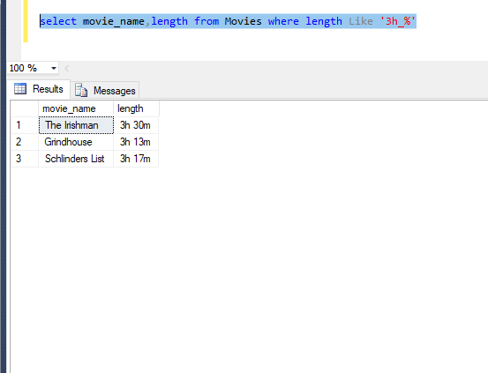

1. Show cinematographer name , id , age where there age gets halved. Rename the row as halved.

Select cnmgraphr_id, cnmgraphr_name, c_age/2 ‘halfed’

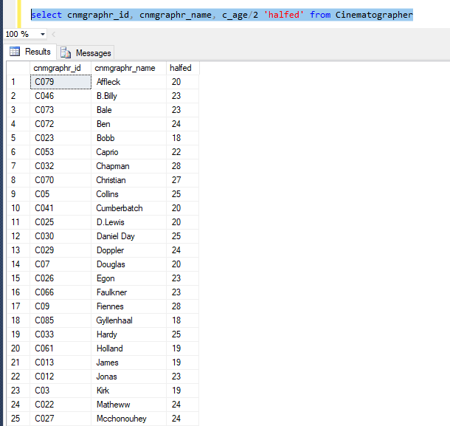

1. Show movie name and the director name in ascending order of release date.

Select m.movie_name, m.release_date, d.director_name from Movies m, Directors d where m.director_id=d.director_id order by m.release_date.

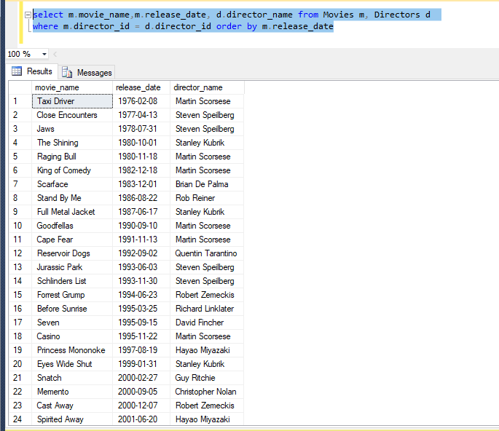

1. Show the number of movies that became Blockbuster in business.

Select count(state) from Business where state = ‘Blockbuster’

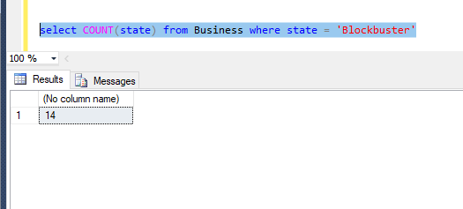

1. Show all the movies which became flop and average in business.

(Select movie_name, state from Business where state = ‘Average’) union (Select movie_name, state from Business where state = ‘Flop’)

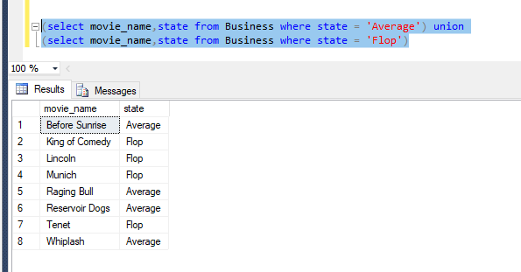

1. Show average agent age,maximum director age, minimum cinematographer age and rename their column.

Select AVG(a.a_age) ‘Agent avg age’, Min(c.c_age)’Cinematographer min age’, Max(d.d_age) ‘Director max age’ from Agent a, cinematographer c, directors d.

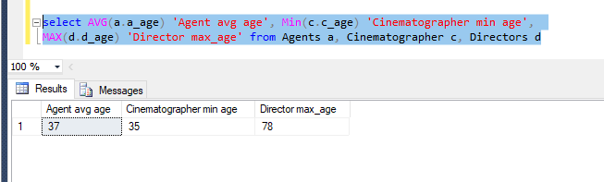

1. Show the director's name and id who hasn’t got any agent to approach.

Select director_id,director_name,agent_id from directors where agent_id is null.

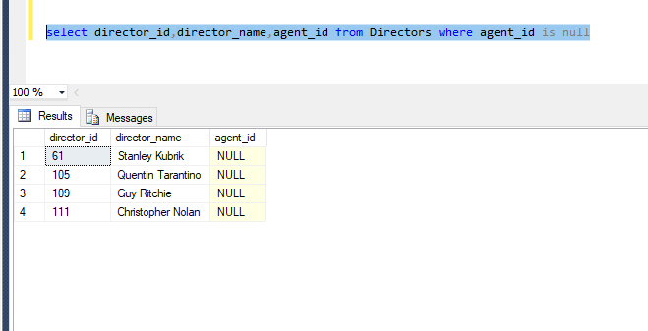

1. Show number of movies each director has directed for A2ZFilms.

Select count (m.director_id), d.director_name from movies m, directors d where m.director_id=d.director_id group by d.director_name.

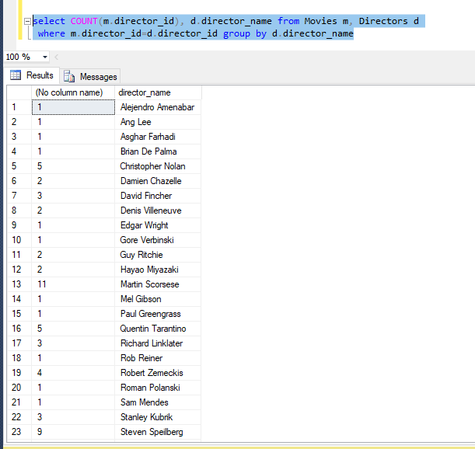

1. Show the movies that has got released between 2000 to 2001.

Select movie_name from Movies where release_date between ‘2000’ and ‘2001’

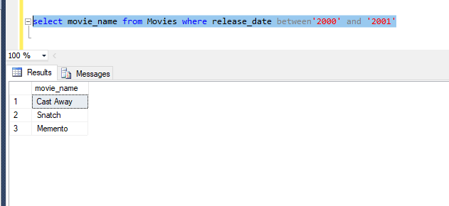

1. Show director name where director age is greater than some directors who has agent id A49.

Select director_name from directors where d_age>some (select d_age from Directors where agent_id = ‘A49’

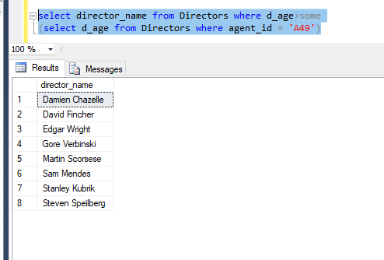

APPENDIX

CREATE DATABASE A2ZFilms

CREATE TABLE [Agents] (

[agent_id] varchar(50),

[agent_name] varchar(50),

[a_age] int,

PRIMARY KEY ([agent_id])

);

CREATE INDEX [Key] ON [Agents] ([agent_name], [a_age]);

CREATE TABLE [Directors] (

[director_id] int,

[director_name] varchar(50),

[agent_id] varchar(50),

[d_age] int,

PRIMARY KEY ([director_id])

);

CREATE INDEX [Key] ON [Directors] ([director_name], [d_age]);

CREATE INDEX [FK] ON [Directors] ([agent_id]);

CREATE TABLE [Movies] (

[movie_name] varchar(50),

[director_id] int,

[genre] varchar(50),

[release_date] date,

[length] varchar(50),

[cnmgraphr_id] varchar(50),

PRIMARY KEY ([movie_name])

);

CREATE INDEX [FK1] ON [Movies] ([director_id]);

CREATE INDEX [Key] ON [Movies] ([genre], [release_date], [length]);

CREATE INDEX [FK2] ON [Movies] ([cnmgraphr_id]);

CREATE TABLE [Cinematographer] (

[cnmgraphr_id] varchar(50),

[cnmgraphr_name] varchar(50),

[c_age] int,

PRIMARY KEY ([cnmgraphr_id])

);

CREATE INDEX [Key] ON [Cinematographer] ([cnmgraphr_name], [c_age]);

CREATE TABLE [Business] (

[movie_name] varchar(50),

[budget] varchar(50),

[box_office] varchar(50),

[state] varchar(50)

);

CREATE INDEX [PK,FK] ON [Business] ([movie_name]);

CREATE INDEX [Key] ON [Business] ([budget], [box_office], [state]);

INSERT INTO agents (agent_id, agent_name, a_age)

VALUES ('A15', 'Coorner', 35),

('A24', 'Ryan', 33),

('A20', 'Reynolds', 37),

('A29', 'Cillian', 30),

('A18', 'Neilson', 41),

('A31', 'Franco', 43),

('A37', 'Kevin', 39),

('A40', 'Spacey', 29),

('A49', 'Anthew', 43),

('A27', 'Hopkins', 29),

('A46', 'Russell', 35),

('A44', 'Crowee', 44),

('A55', 'Joseph', 50),

('A63', 'Gordon', 42),

('A69', 'Levitt', 47),

('A58', 'Gosling', 36),

('A89', 'Hemsworth', 32),

('A77', 'Ruffalo', 38)

('A93, 'Korbin', 39);

('A92', 'Miles', 42);

INSERT INTO directors (director_id, director_name, agent_id, d_age)

VALUES (0103, 'Robert Zemeckis', 'A15', 52),

(0203, 'Takashi Shimizu', 'A24', 49),

(075, 'Martin Scorsese', 'A15', 77),

(0105, 'Quentin Tarantino', Null, 47),

(0111, 'Christopher Nolan', Null, 44),

(076, 'Steven Speilberg', 'A18', 77),

(0109, 'Guy Ritchie', Null, 50),

(061, 'Stanley Kubrik', Null, 78),

(0115, 'Richard Linklater', 'A20', 55),

(0153, 'Hayao Miyazaki', 'A31', 53),

(0148, 'Denis Villeneuve', 'A37', 54),

(0136, 'Ang Lee', 'A31', 42),

(0151, 'Mel Gibson', 'A40', 41),

(0155, 'Paul Greengrass', 'A49', 58),

(0143, 'Alejendro Amenabar', 'A29', 57),

(0159, 'Rob Reiner', 'A27', 51),

(0142, 'Edgar Wright', 'A46', 63),

(0150, 'Gore Verbinski', 'A44', 65),

(0120, 'Asghar Farhadi', 'A55', 44),

(0180, 'Brian De Palma', 'A63', 49),

(0201, 'Damien Chazelle', 'A69', 60),

(0128, 'David Fincher', 'A58', 60),

(0303, 'Sam Mendes', 'A89', 59),

(0182, 'Roman Polanski', 'A77', 54);

INSERT INTO cinematographer (cnmgraphr_id, cnmgraphr_name, c_age)

VALUES ('C05', 'Collins', 50),

('C018', 'Ralph', 55),

('C09', 'Fiennes', 57),

('C032', 'Chapman', 56),

('C051', 'Paul', 43),

('C034', 'Schrader', 44),

('C043', 'R.Webb', 47),

('C019', 'Weisly', 38),

('C080', 'Michael', 43),

('C022', 'Matheww', 49),

('C027', 'Mcchonouhey', 48),

('C011', 'Tom', 50),

('C033', 'Hardy', 51),

('C035', 'Thomas', 52),

('C014', 'Shelby', 45),

('C012', 'Jonas', 46),

('C015', 'Tiedmann', 48),

('C026', 'Egon', 47),

('C029', 'Doppler', 49),

('C030', 'Daniel Day', 51),

('C025', 'D.Lewis', 40),

('C07', 'Douglas', 41),

('C03', 'Kirk', 39),

('C023', 'Bobb', 37),

('C040', 'Nicholson', 35),

('C010', 'Robin', 36),

('C017', 'Williams', 39),

('C013', 'James', 39),

('C066', 'Faulkner', 47),

('C053', 'Caprio', 44),

('C070', 'Christian', 54),

('C072', 'Ben', 48),

('C073', 'Bale', 47),

('C075', 'Stewart', 41),

('C079', 'Affleck', 40),

('C061', 'Holland', 39),

('C085', 'Gyllenhaal', 37),

('C086', 'Pessci', 49),

('C089', 'Willder', 44),

('C046', 'B.Billy', 46),

('C041', 'Cumberbatch', 41);

INSERT INTO movies (movie_name, director_id, genre, release_date, length, cnmgraphr_id)

VALUES ('Forrest Grump', 0103, 'Comedy-Drama', '1994-06-23', '2h 32m', 'C05'),

('Cast Away', 0103, 'Adventure', '2000-12-07', '2h 23m', 'C018'),

('The Walk', 0103, 'Adventure', '2015-08-15', '2h 3m', 'C09'),

('Welcome to Marween', 0103, 'Fantasy', '2018-12-21', '1h 56m', 'C09'),

('The Grudge', 0203, 'Horror', '2004-10-22', '1h 36m', 'C032'),

('Taxi Driver', 075, 'Drama', '1976-02-08', '1h 54m', 'C051'),

('Raging Bull', 075, 'Drama', '1980-11-18', '2h 9m', 'C034'),

('King of Comedy', 075, 'Comedy', '1982-12-18', '1h 49m', 'C051'),

('Goodfellas', 075, 'Crime', '1990-09-10', '2h 22m', 'C051'),

('Casino', 075, 'Crime', '1995-11-22', '2h 58m', 'C051'),

('Cape Fear', 075, 'Suspense', '1991-11-13', '2h 8m', 'C043'),

('The Aviator', 075, 'Biography', '2004-12-14', '2h 50m', 'C019'),

('The Departed', 075, 'Thriller', '2006-09-16', '2h 31m', 'C019'),

('Shutter Island', 075, 'Mystery', '2010-02-13', '2h 19m', 'C080'),

('Gangs of NewYork', 075, 'Crime', '2002-03-29', '2h 50m', 'C051'),

('The Irishman', 075, 'Crime', '2019-11-11', '3h 30m', 'C051'),

('Django Unchained', 0105, 'Western', '2012-12-25', '2h 45m', 'C018'),

('Inglorious Bastards', 0105, 'War', '2009-07-28', '2h 33m', 'C022'),

('Kill Bill', 0105, 'Action', '2003-10-10', '1h 52m', 'C027'),

('Kill Bill 2', 0105, 'Action', '2004-04-08', '2h 18m', 'C027'),

('Reservoir Dogs', 0105, 'Crime', '1992-09-02', '1h 40m', 'C011'),

('Insomnia', 0111, 'Thriller', '2002-05-24', '1h 55m', 'C080'),

('Memento', 0111, 'Mystery', '2000-09-05', '1h 52m', 'C033'),

('Dunkirk', 0111, 'War', '2017-07-13', '1h 46m', 'C035'),

('The Prestige', 0111, 'Mystery', '2006-10-17', '2h 10m', 'C035'),

('Tenet', 0111, 'Sci-fi', '2020-01-01', '2h 34m', 'C014'),

('Jurassic Park', 076, 'Adventure', '1993-06-03', '2h 7m', 'C012'),

('A.I.', 076, 'Sci-fi', '2001-06-26', '2h 26m', 'C015'),

('Schlinders List', 076, 'War', '1993-11-30', '3h 17m', 'C026'),

('The Terminal', 076, 'Rom-Com', '2004-06-09', '2h 8m', 'C029'),

('Lincoln', 076, 'Drama', '2012-10-08', '2h 30m', 'C030'),

('Minority Report', 076, 'Sci-fi', '2002-06-17', '2h 26m', 'C029'),

('Munich', 076, 'Drama', '2005-12-23', '2h 44m', 'C025'),

('Jaws', 076, 'Horror', '1978-07-31', '2h 13m', 'C07'),

('Close Encounters', 076, 'Sci-fi', '1977-04-13', '2h 15m', 'C03'),

('Snatch', 0109, 'Comedy', '2000-02-27', '1h 44m', 'C023'),

('The Gentlemen', 0109, 'Action', '2019-11-09', '1h 53m', 'C040'),

('The Shining', 061, 'Horror', '1980-10-01', '2h 26m', 'C010'),

('Eyes Wide Shut', 061, 'Mystery', '1999-01-31', '2h 39m', 'C017'),

('Full Metal Jacket', 061, 'War', '1987-06-17', '1h 56m', 'C013'),

('Before Sunrise', 0115, 'Romance', '1995-03-25', '1h 45m', 'C066'),

('Before Sunset', 0115, 'Romance', '2004-06-17', '1h 20m', 'C066'),

('Before Midnight', 0115, 'Romance', '2013-05-22', '1h 50m', 'C066'),

('Princess Mononoke', 0153, 'Animation', '1997-08-19', '2h 6m', 'C053'),

('Spirited Away', 0153, 'Animation', '2001-06-20', '2h 5m', 'C053'),

('Prisoners', 0148, 'Mystery', '2013-09-18', '2h 33m', 'C025'),

('Arrival', 0148, 'Sci-fi', '2016-09-02', '1h 55m', 'C070'),

('Life Of Pi', 0136, 'Adventure', '2012-11-21', '2h 7m', 'C072'),

('Hacksaw Ridge', 0151, 'War', '2016-10-16', '2h 17m', 'C073'),

('Captain Phillips', 0155, 'Action', '2013-10-10', '2h 13m', 'C073'),

('The Others', 0143, 'Horror', '2001-08-02', '1h 44m', 'C075'),

('Stand By Me', 0159, 'Adventure', '1986-08-22', '1h 29m', 'C034'),

('Grindhouse', 0142, 'Horror', '2007-04-06', '3h 13m', 'C079'),

('The Ring', 0150, 'Horror', '2002-10-02', '2h 25m', 'C061'),

('A Seperation', 0120, 'Drama', '2011-03-16', '2h 3m', 'C011'),

('Scarface', 0180, 'Crime', '1983-12-01', '2h 50m', 'C022'),

('La La Land', 0201, 'Romance', '2018-09-11', '2h 8m', 'C070'),

('Whiplash', 0201, 'Drama', '2014-01-23', '1h 47m', 'C085'),

('Seven', 0128, 'Crime', '1995-09-15', '2h 8m', 'C086'),

('Gone Girl', 0128, 'Thriller', '2014-09-29', '2h 29m', 'C089'),

('The Social Network', 0128, 'Biography', '2010-10-01', '2h 1m', 'C089'),

('1917', 0303, 'War', '2019-12-04', '1h 59m', 'C046'),

('The Pianist', 0182, 'Biography', '2002-09-06', '2h 25m', 'C041');

INSERT INTO business (movie_name, budget, box_office, state)

VALUES ('Forrest Grump', '55m USD', '678m USD', 'Big-Blockbuster'),

('Cast Away', '90m USD', '429m USD', 'Blockbuster'),

('The Walk', '35m USD', '61m USD', 'Hit'),

('Welcome to Marween', '39m USD', '13m USD', 'Disaster'),

('The Grudge', '10m USD', '187m USD', 'Super-hit'),

('Taxi Driver', '2m USD', '30m USD', 'Hit'),

('Raging Bull', '18m USD', '24m USD', 'Average'),

('King of Comedy', '19m USD', '3m USD', 'Flop'),

('Goodfellas', '25m USD', '47m USD', 'Hit'),

('Casino', '40m USD', '116m USD', 'Super-hit'),

('Cape Fear', '35m USD', '182m USD', 'Super-hit'),

('The Aviator', '110m USD', '213m USD', 'Super-hit'),

('The Departed', '90m USD', '292m USD', 'Blockbuster'),

('Shutter Island', '80m USD', '295m USD', 'Blockbuster'),

('Gangs of NewYork', '100m USD', '194m USD', 'Super-hit'),

('The Irishman', '177m USD', '8m USD', 'Disaster'),

('Django Unchained', '100m USD', '426m USD', 'Blockbuster'),

('Inglorious Bastards', '70m USD', '321m USD', 'Blockbuster'),

('Kill Bill', '30m USD', '181m USD', 'Super-hit'),

('Kill Bill 2', '30m USD', '152m USD', 'Super-hit'),

('Reservoir Dogs', '2m USD', '7m USD', 'Average'),

('Insomnia', '46m USD', '113m USD', 'Hit'),

('Memento', '9m USD', '39m USD', 'Hit'),

('Dunkirk', '150m USD', '526m USD', 'Blockbuster'),

('The Prestige', '40m USD', '109m USD', 'Hit'),

('Tenet', '205m USD', '121m USD', 'Flop'),

('Jurassic Park', '63m USD', '1B USD', 'Big-Blockbuster'),

('A.I.', '100m USD', '235m USD', 'Super-hit'),

('Schlinders List', '22m USD', '322m USD', 'Blockbuster'),

('The Terminal', '60m USD', '219m USD', 'Super-hit'),

('Lincoln', '65m USD', '59m USD', 'Flop'),

('Minority Report', '102m USD', '358m USD', 'Super-hit'),

('Munich', '70m USD', '54m USD', 'Flop'),

('Jaws', '9m USD', '470m USD', 'Blockbuster'),

('Close Encounters', '20m USD', '306m USD', 'Blockbuster'),

('Snatch', '10m USD', '84m USD', 'Hit'),

('The Gentlemen', '22m USD', '115m USD', 'Hit'),

('The Shining', '19m USD', '46m USD', 'Hit'),

('Eyes Wide Shut', '60m USD', '162m USD', 'Super-hit'),

('Full Metal Jacket', '30m USD', '120m USD', 'Hit'),

('Before Sunrise', '2m USD', '5m USD', 'Average'),

('Before Sunset', '3m USD', '16m USD', 'Hit'),

('Before Midnight', '3m USD', '23m USD', 'Hit'),

('Princess Mononoke', '23m USD', '159m USD', 'Super-hit'),

('Spirited Away', '18m USD', '347m USD', 'Blockbuster'),

('Prisoners', '46m USD', '122m USD', 'Hit'),

('Arrival', '47m USD', '203m USD', 'Super-hit'),

('Life Of Pi', '120m USD', '609m USD', 'Blockbuster'),

('Hacksaw Ridge', '40m USD', '180m USD', 'Super-hit'),

('Captain Phillips', '55m USD', '218m USD', 'Super-hit'),

('The Others', '17m USD', '209m USD', 'Super-hit'),

('Stand By Me', '8m USD', '53m USD', 'Hit'),

('Grindhouse', '67m USD', '21m USD', 'Disaster'),

('The Ring', '48m USD', '249m USD', 'Super-hit'),

('A Seperation', '1m USD', '24m USD', 'Hit'),

('Scarface', '37m USD', '66m USD', 'Hit'),

('La La Land', '30m USD', '446m USD', 'Blockbuster'),

('Whiplash', '23m USD', '27m USD', 'Average'),

('Seven', '33m USD', '327m USD', 'Blockbuster'),

('Gone Girl', '61m USD', '369m USD', 'Blockbuster'),

('The Social Network', '40m USD', '224m USD', 'Super-hit'),

('1917', '100m USD', '368m USD', 'Super-hit'),

('The Pianist', '35m USD', '120m USD', 'Hit');